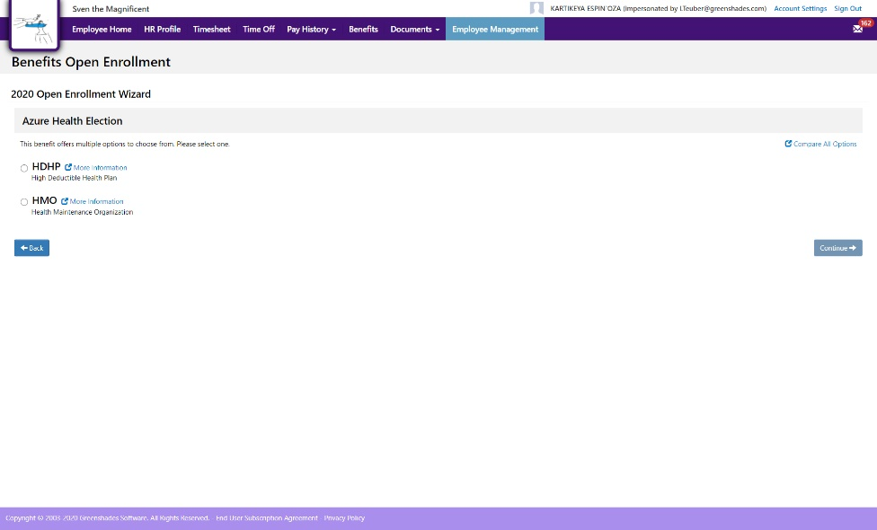
  [Company Name]
    - Employee Open Enrollment Overview

Enrolling in Benefits with GreenEmployee
Welcome to Open Enrollment with [enter company name] through GreenEmployee! Enrolling in benefits is easy, but this guide will walk you through how to prepare for Open Enrollment, how to enroll in benefits, and how to check your benefits anytime using the GreenEmployee portal at xyz.greenemployee.com.

Before Enrollment Checklist
Prior to Open Enrollment, please make sure to review the following checklist to ensure a smooth enrollment experience using GreenEmployee. Should you run into any issues, please reach out to HR Department at email@domain.com for assistance.
 | Access your GreenEmployee account. Make sure you have either set up your GreenEmployee account, or if you choose to not set up an account, follow the step to access GreenEmployee without an account set up.
 | Review your personal information. Review your profile information in GreenEmployee to make sure everything is up to date. This includes information like your address, phone number, birthdate, etc.
 | Review your dependent information. Ensure all of your dependents are entered under your profile information. If there is a dependent missing, make sure to add their information well before you start Open Enrollment.
 | Print or download a copy of your current enrollment. If you completed enrollment with [enter company name] in the past, have a copy of your current elections available prior to starting Open Enrollment. That way, you can easily reference the plans you have previously enrolled in.
 | Review next year’s benefit options. Before you begin enrollment, make sure you know what the options are. If you are currently enrolled in benefits and choose to switch offerings, make sure that your current providers are still in-network.

Open Enrollment FAQ
Check out these commonly asked questions about Open Enrollment from employees much like yourself.

How do I see my profile information?
From your Benefits, you can view your most up to date profile information, including address, personal information, and dependent information. .

How do I access my current enrollment?
On GreenEmployee, navigate to the ‘Benefits’ page from the top level menu. On the Benefits page, you can view a full list of your current enrollment under “Current Enrollment”. Select ‘More Details’ to view coverage and deductible information.

How do I see what I enrolled in last Open Enrollment?
On the Benefits page in GreenEmployee, navigate to the righthand column titled ‘Enrollment Events’. Select the “View History” button. This will show you a full list of enrollment events you have completed in GreenEmployee. From here, you can download a PDF snapshot of all the details of your enrollment during last years Open Enrollment.

Open Enrollment: How to Enroll in Benefits
Now that you have successfully completed the Before Enrollment Checklist, its time to begin your Open Enrollment!
After logging into GreenEmployee, navigate to the Benefits tab on your GreenEmployee Homepage.
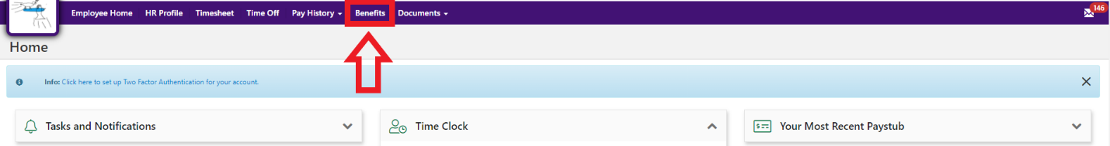
Here, you will find all of your Benefits information. This includes your current benefit enrollment, any elections you have selected that are pending administrator approval, any elections for the upcoming plan year that have been approved by your administrator, and all benefits you are eligible for in your current plan year.
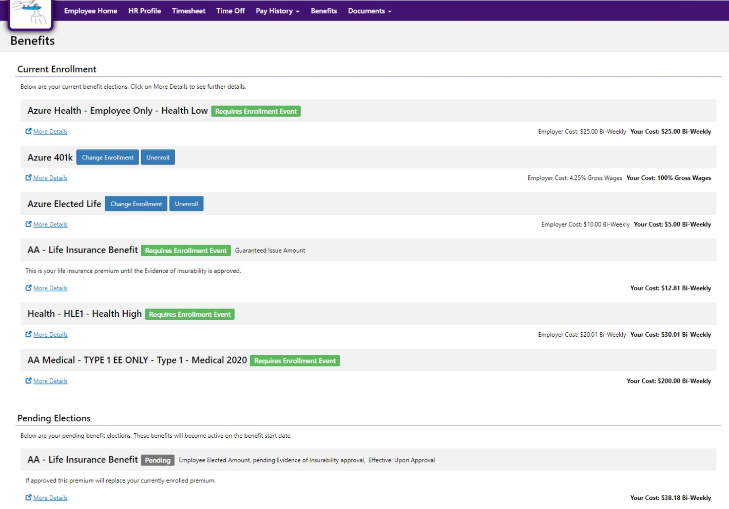
On the far right of the screen, you will see a section labeled “Enrollment Events”. Under this section, you will see your Open Enrollment event.
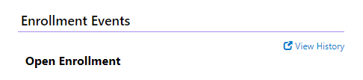
Select the button to “Begin Enrollment”. This will redirect you to the Open Enrollment Wizard, which will display all benefits you are eligible for in this Open Enrollment. To enroll in a benefit you are interested in, select “Enroll” next to that benefit. If you would not like to enroll in that benefit, select “Waive”.
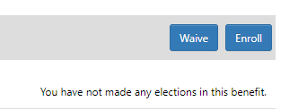
[enter plan specific or benefit specific information here]
Once you have enrolled in all of the benefits you wish to select and waived all benefits you wish to pass on, you will see a total cost at the bottom of the screen. This will display [your total cost per pay check, as well as your employers cost per pay check **may vary depending on company settings]. Review this amount to ensure it is correct. Once you verified that this number is correct, enter your signature where it says “Sign and Submit”, then select the “Sign and Submit” button. This will submit your elections to your benefits administrator for review.
You will then be redirected back to the Benefits home page. You will be able to review your Open Enrollment event under the “View History” button of your Enrollment Events. You can also review your pending and future elections that you enrolled into.

Once your elections are approved by your administrator, they will go from the “Pending Elections” to the “Future Elections” section on your home page.

