Product Guide and FAQ




Greenshades Software Support Team
support@greenshades.com
1-888-255-3815

General Overview

About Greenshades Garnishments
The Greenshades Garnishment product was designed to provide our Dynamics GP clients with a convenient way of properly tracking and deducting garnishments for their employees. In addition to calculating garnishments based off state specific rules, Greenshades Garnishments also provides you with the ability to track arrears, generate helpful reports, and create ACH payments. Greenshades Garnishments also has the ability to handle confliction and pro-ration of garnishments.

Requirements for Greenshades Garnishments
Greenshades Garnishments does have a couple of prerequisites in order to function properly. First, it requires an active internet connection. Greenshades does not offer an “Offline Mode” or any way to operate without an active internet connection.

Greenshades Garnishments can be configured to authenticate with a corporate proxy server, but it is our client’s responsibility to ensure that adequate internet access is provided to the Greenshades Center. For information on setting up Greenshades with your Proxy Server or Firewall, please see our Firewall Guide available at: http://www.greenshades.com/pub/downloads/documentation/firewallguide.pdf

Also, Greenshades Garnishments requires an update to Microsoft Windows called the ‘Microsoft .NET Framework.’ Please install version 2.0 or later of this component.

While a user will not need to be a computer administrator or logged into Dynamics as System Administrator (SA), they will need to have permission to write to the file system and the registry and may need to have an authorized user provide an administrative database password when performing some updates.

Installing Greenshades Garnishments
To install Greenshades Garnishments you will need to run the “GarnishmentsSetup.msi” file available on our website, http://www.greenshades.com/pub/downloads/garnishmentssetup.msi.

This is a Microsoft Installer and will ask you to choose a location for the product and choose the installation directory of your accounting package. Once it has completed, Greenshades Garnishments will be installed on your workstation.

Further information for installing Greenshades Garnishments can be found within our Installation Guide at:
http://www.greenshades.com/pub/downloads/documentation/GarnishmentInstallation.pdf

Launching Greenshades Garnishments
Greenshades Garnishments can be accessed through Dynamics GP by navigating from the top bar menu through Cards > Payroll > Garnishments.

The program will also automatically launch every time you calculate checks within Dynamics.

Initial Setup of Garnishments
When you launch Greenshades Garnishments for the first time you will need to enter in your registration key. Your registration key would have been emailed to you once you completed your purchase. You can also find your registration key on the MyGreenshades web portal at http://www.greenshades.com/mygreenshades.

After entering in your registration key, click the Apply button. You will only need to enter in your registration key the first time you launch Greenshades Garnishments. After validating your registration key, click OK to enter into Greenshades Garnishments.

Basic Navigation within Greenshades Garnishments
The functionality of Greenshades Garnishments is separated into six separate wizards that provide you with the ability to complete multiple tasks including setting up multiple garnishments, track arrearage, convert garnishments into Payables Transactions, and create reports. This section of the user guide will briefly go over the functionality of each wizard.

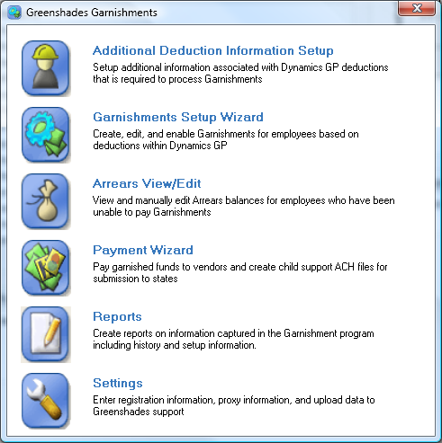

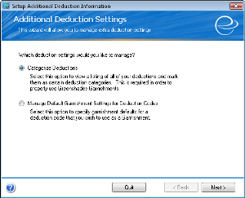
Additional Deduction Information Setup

The first step in ensuring your garnishments will be properly calculated is to go through the ‘Additional Deduction Information Setup’. Once selected you will have two options

- Catagorize Deductions

- Manage Default Garnishment Settings For Deduction Codes

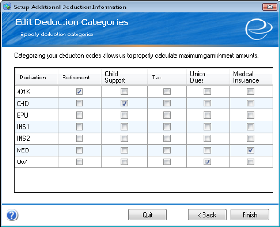

Catagorize Deductions

During this setup you will categorize your deductions into certain deduction categories, Retirement, Child Support, Tax, Union Dues, and Medical Insurance. Correctly categorizing your deductions will enable Greenshades Garnishments to properly calculate maximum garnishment amounts when exemptions are involved. If the deduction does not apply to any of the listed categories leave it blank. Note: If you categorize a deduction as a “Tax” then it will be deducted from gross pay when calculating disposable income.

Manage Default Garnishment Settings For Deduction Codes

In this stage of the setup, we will specify the default values for any existing deductions. These default values will be used when an employee has a garnishment with the specific deduction code. You will however, be able to change the values per employee. Managing the defaults is broken down into four stages:

- Select Deduction
- Edit Garnishment Settings
- Garnishment Settings
- Select Vendor and Check book

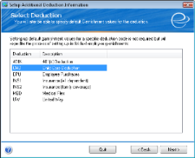
Select Deduction

Choose the deduction in which you would like to set the defaults

.

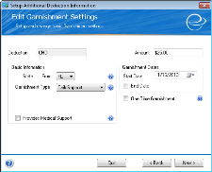
Edit Deduction Settings

Select the default state and amount that will apply to this deduction code. You must also specify what type of garnishment that this deduction code is in reference to.

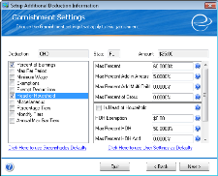
Garnishment Settings

This is where you will setup the default rules that will be applicable to this deduction code. Greenshades suggests that you use the Greenshades Defaults as the default values. We have done extensive research to determine the default state laws for various types of garnishments. To apply these rules, click the link in the lower left hand section of the page. If Greenshades defaults are not available, you can specify your own default rules that will apply to this deduction code.

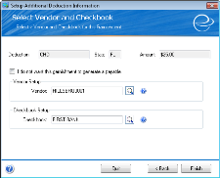
Select Vendor and Checkbook

This is the final stage of setting up your defaults. You can select a vendor and a checkbook to be associated with this garnishment. If you find that this is too general of a decision you may check the checkbox above the vendor selection and opt to not create a default payable. You will still be able to set these fields per employee in the Garnishment Setup Wizard.

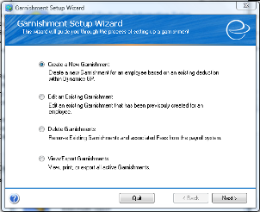
Garnishment Setup Wizard

After you have properly gone through the Additional Deduction Information you are ready to setup your garnishments. The Garnishment Setup Wizard is where all the garnishment setup and management is located. The Garnishment Setup Wizard is probably the most used portion of Greenshades Garnishments. This wizard guides you through creating new garnishment, editing an existing garnishment, deleting a garnishment, and creating a report of all active garnishments.

Create a New Garnishment

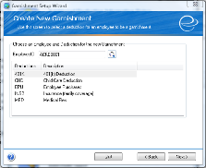
This is where you will setup each employee garnishment. This process is similar to setting up the defaults for each deduction with the exception that it is employee specific. Along with garnishment setup you will also be able to apply an optional fee with associated rules. Greenshades has also done research to find the default state laws for applying fees associated with garnishments. We recommend that you use our settings.

In order to create a garnishment, click the magnifying glass button and select an employee that needs a garnishment setup. Click the next button. Note: The deduction code must already be associated with the employee in GP before it will be listed on this menu screen.

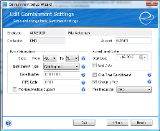

This will bring you to the ‘Edit Garnishment Settings’ screen. Here is where you will setup the employee specific information for this garnishment. If the garnishment is for a child support, select the state ‘From’ where the employee works and also ‘To’, the state that the payment is being sent to. Also, if the garnishment being set up is for a child support, a case number is required. On this screen you can also opt to ‘Charge a Fee’.

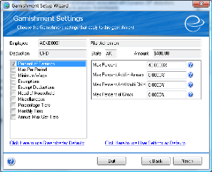
The next step is to setup the rules that will apply to this garnishment. You can select the defaults from Greenshades or if you created different default values for this deduction code in the ‘Additional Deduction Information’ section you can select the ‘Use User Settings as Defaults’ link to fill the garnishment settings with values or you can define unique rules for this specific employee.

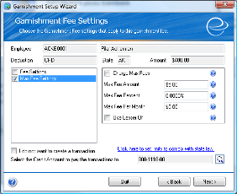

After setting the garnishment rules for this employee, if you opted to charge a fee for this garnishment the next screen will let you set the rules associated with this fee. Once again, Greenshades recommends that you use our default values when applying these rules. If you have setup Dynamics GP to handle fee transactions you can click the ‘I do not want to create a transaction’ to not create a GL entry for this fee.

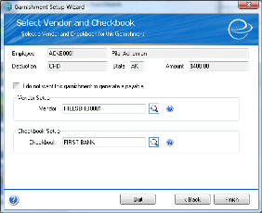

The last page in this wizard is where you will select the vendor and checkbook that will be associated in the payment of this garnishment. If you do not wish to create a payable, select the checkbox located above the vendor field. Note: In order for this employee’s garnishment to be available in the Payment Wizard, you must select a Vendor and Checkbook on this menu screen.

Edit an Existing Garnishment

In order to edit an existing garnishment, select the magnifying glass and choose an employee. Only employees with garnishments are listed. Pick the garnishment to edit and click next. Only certain fields on the ‘Edit Garnishment Settings’ screen are available to edit. For example, the ‘From’ state is not editable. If you need to change the state of an existing garnishment you will need to delete the garnishment then recreate it with the correct state using the process described above. Clicking next will take you to the rules portion of the wizard. You may modify this section as you see fit. The final two screens are identical to the final two screens of the ‘Create a New Garnishment’ process. Handle these screens in the same manner.

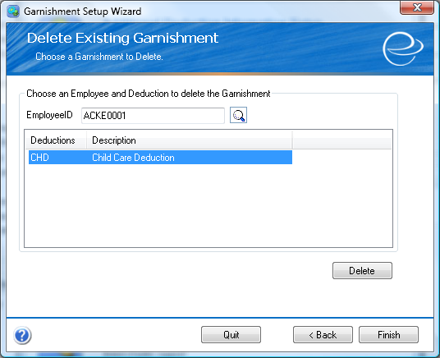

Delete Existing Garnishment

Choose the magnifying glass button and select an employee with a garnishment. Click next. Now select the garnishment that you wish to delete and click the ‘Delete’ button. Click Finish when complete.

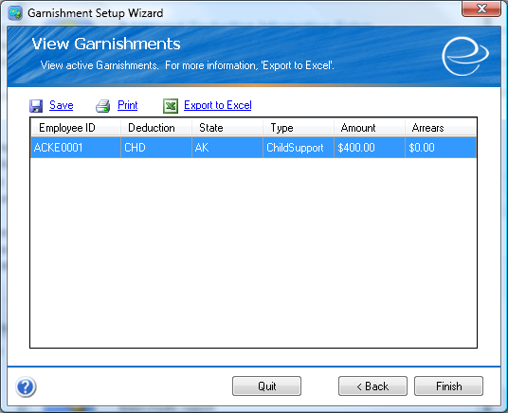

View/Export Garnishments

Here you can view all of your garnishments. You can also print, export to Excel, or save the list of garnishments.

Arrears View/Edit

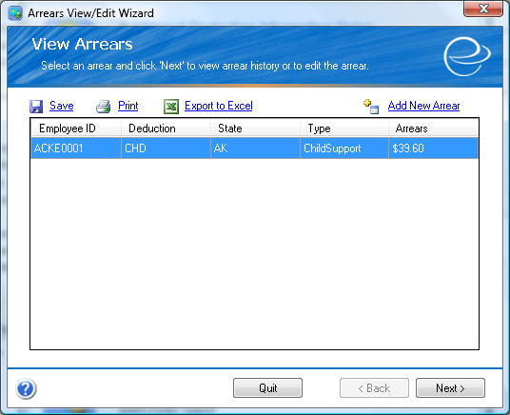
In order for Greenshades Garnishments to properly track amounts in arrears, you will need to input the current balance employees have in arrears. To add arrears first launch the View/Edit Arrears Wizard and then click on the ‘Add New Arrears’ link, this will bring up a separate Add New Arrear window.

Use the magnifying glass to select the employee and then select the garnishment you need to add arrears for and type in the appropriate amount. Please note, that you will only be able to add an arrear for any employee that you have setup using the Garnishment Setup Wizard.

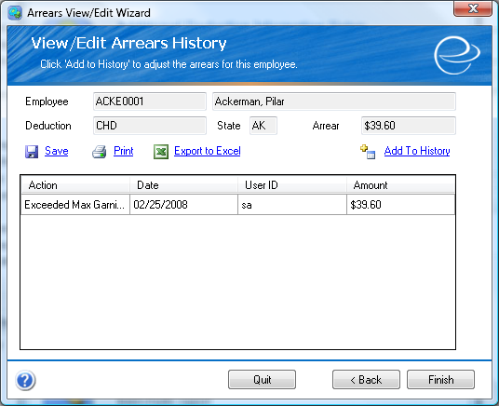
Within the Arrears portion of Greenshades Garnishments you can view and manually edit arrear balances for employees who have been unable to pay garnishments. You will also be able to view the arrear history.

To make an edit to the arrear balance, click on the ‘Add to History’ link, this will bring up a separate Add Arrears History window.

To increase the amount in arrears, just type the amount in the Amount field on the Add Arrears History window. To decrease the amount in arrears, type in the amount as a negative number on the Add Arrears History window. After making the appropriate adjustments, click the Add button, this will bring you back to the View/Edit Arrears History screen. You will now see the edit you just made to this arrear. Click Finish to bring you back to the main Greenshades Garnishments window.

Payment Wizard

In this section, you will create check transactions, General Ledger entries for fees, and Child Support ACH files. As well as manage the status of existing payments.

Create Payments for Garnishments

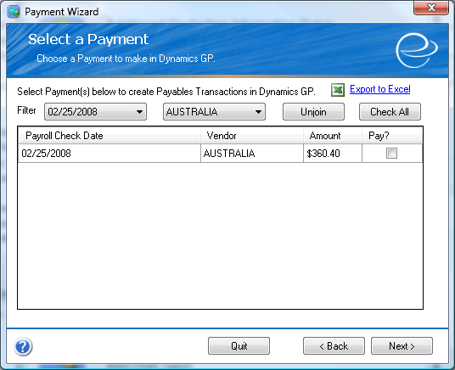
The first step in payment creation is to select a payment to pay. You can use the filters to view only the desired payments. You can click unjoin to separate the payments that have been grouped according to vendor and check date. Doing so allows you to make payments towards specific employee garnishments. Once a group has been “unjoined” and a check transaction has been created, the remaining group members will not be able to be rejoined. Also, keep in mind that only garnishments that have vendors and checkbooks associated with them will show up in this payables screen. Finally, select the payments that you wish to create by checking the ‘Pay?’ checkbox.

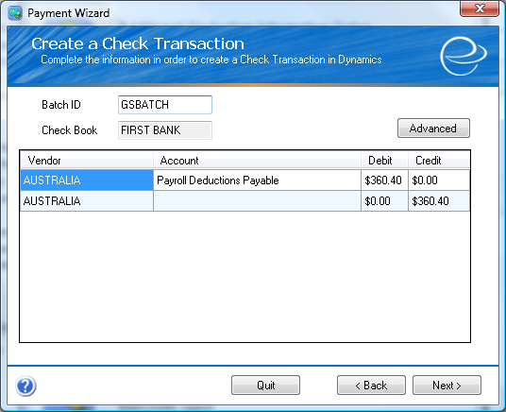
Create Check Transaction

After selecting the payment that you wish to pay, you will come to this screen. First you must enter a batch Id. This id will be sent to GP. Next you will verify that you are using the correct checkbook. If you wish to specify settings that will help to identify the check transaction, click the ‘Advanced’ button and choose the desired settings.

Now you will have the option to either click Next or Finish. If the wizard is displaying the next button on this screen this means that the payment you selected is also a child support payment and the next button will create the transaction then take you to the Create ACH file screen where you can optionally create and save an ACH file for this payment.

If the finish button is displayed, clicking it will create the transaction with the corresponding batch Id in GP.

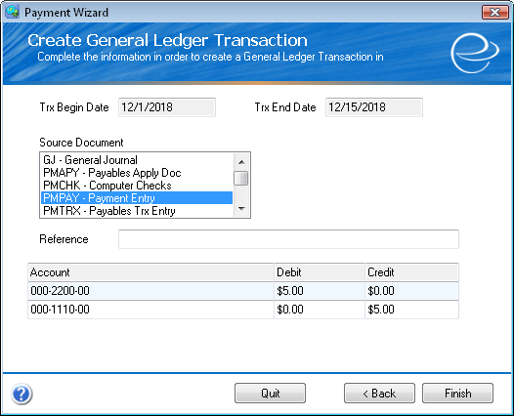
Create General Ledger Entries for Garnishment Fees

The first step in this process is to select the fee in which you would like to create a GL entry. Once you have completed this click next.

Fill the fields in this screen with information pertaining to this specific fee. Once completed click Finish.

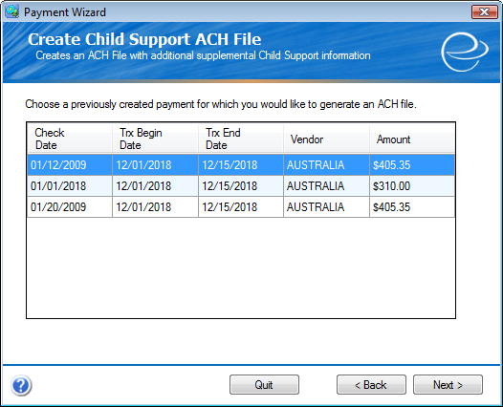
Create ACH File

Greenshades Garnishments is capable of creating Child Support ACH files in the correct state specified format. To do this, select a payment that you wish to create an ACH file for and click next.

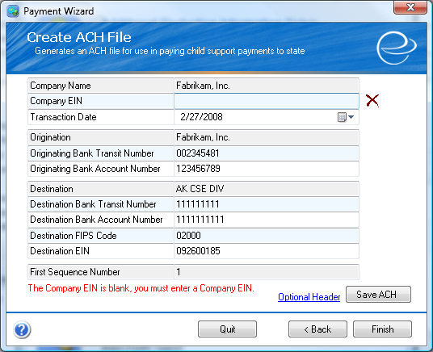
Now enter the requested information in any blank fields and click save. If your financial organization requires that you have the optional header filled in then click the ‘Optional Header’ link. Once you have the information filled in, save the file to a location on your computer. Finally, click Finish to return to the main Greenshades Garnishments window.

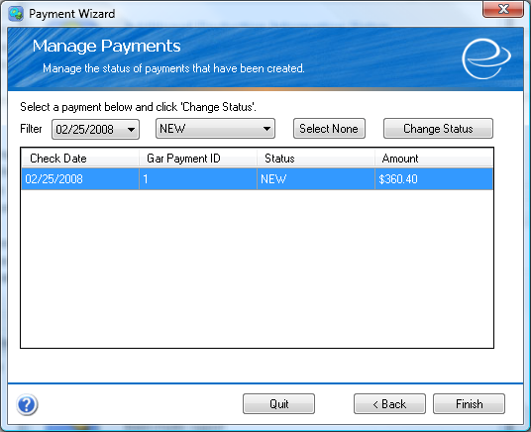
Manage Payments

In this section you have the ability to change the status of existing payments. You can mark selected payments as New, Created, Posted, or you can Delete a payment. To do this, select a payment or payments and click the ‘Change Status’ button. From here, you can view various information about the selected payment as well as change the status. Once you have completed managing the status of your payments click Finish to return to the main Greenshades Garnishments window.

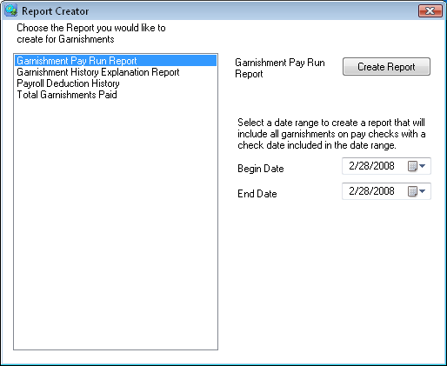

Reports

Greenshades Garnishments comes equipped with the ability to create various helpful reports. These reports can be filtered to display only entries between the specified dates.

Calculate Garnishments
Once you have completed the process of setting up your employee garnishments within Greenshades Garnishment, you are ready to begin to having Greenshades Garnishments calculate your employee’s garnishments.

Step 1
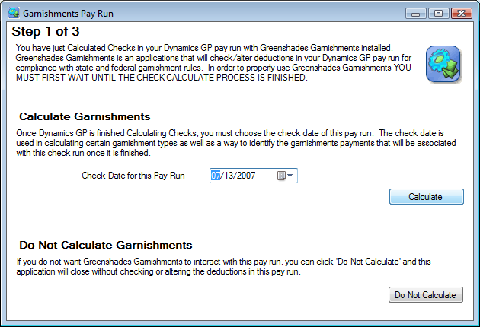
After installing Greenshades Garnishments, the program will automatically launch every time you calculate checks within Dynamics. If you have not yet setup Greenshades Garnishments entirely and do not wish to have Greenshades Garnishments calculate your garnishments, click the ‘Do Not Calculate’ button when the product launches.

After the calculation process in Dynamics has completed (even though Greenshades Garnishments may launch before the calculation is finished, you must wait), select the appropriate check date for the pay run, and click the ‘Calculate’ button.

Step 2
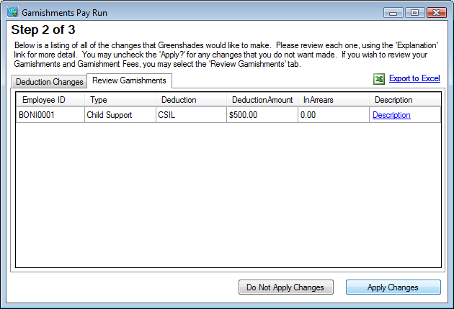
The second step to calculating garnishments is to review the deduction changes recommended based upon Greenshades Garnishments’ calculations. Here you see a list of deduction changes where Greenshades Garnishments’ calculations do not match Dynamics GP deduction calculations. To view an explanation of the recommended change click the ‘View Explanation’ link.

If you agree with the Greenshades Garnishments’ calculation, leave the Apply? Box checked. If you disagree, uncheck the Apply? box.

To review the amount being garnished, select the Review Garnishment tab. This list shows all the garnishments that are being deducted from your employees as well as any amount that will be placed in arrears. To view an explanation of the garnishment calculation, click the ‘Explanation’ link.

Once you have reviewed the information on the Deduction Changes and Review Garnishments tab, you will need to select if you wish to have these changes update your Dynamics pay run. To include the changes recommended by Greenshades Garnishments, select the ‘Apply Changes’ button. If you do not wish to include the recommended changes, use the ‘Do Not Apply Changes’ button.

Step 3
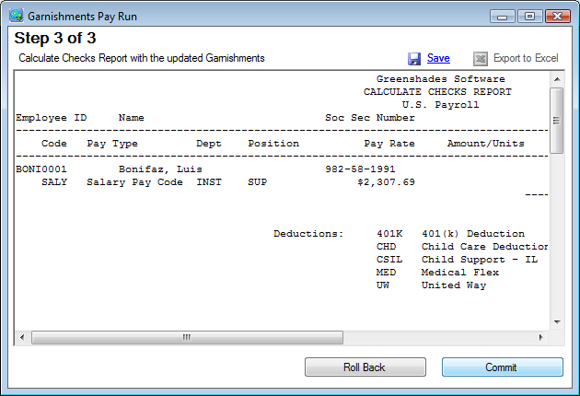
You will now see an updated Calculate Checks report that includes the information from the previous step.

To update the Dynamics information with the information shown on this report, click Commit. Otherwise select the Roll Back button. This button will close the Greenshades Garnishment pay run without applying any changes.

Settings

The information on the Settings screen will not need to be used by most of our users with the exception of the initial setup. The registration key and any necessary proxy server information is stored within the Settings screen. Information useful to Greenshades Support is also found within the Settings screen on the Upload Data, Log File, and About tabs.
If you have questions about Greenshades Garnishments after reviewing this guide, please contact Greenshades Support via email at support@greenshades.com or by calling 888-255-3815 extension 700.

Frequently Asked Questions
Here we have provided some of our most commonly asked questions. Many of these are problems that people have encountered while running the Greenshades Center and possible workarounds to those problems.

I am not familiar with Greenshades Garnishments, can I get a walkthrough?
Yes, Greenshades technical support has limited walkthrough appointments available. Walkthroughs are available during business hours except the week prior to any major filing deadline. To schedule a walkthrough please contact Greenshades Support via email at support@greenshades.com or by calling 888-255-3815 extension 700.

How can I get live support?
Live support comes with Greenshades Software. You can access Greenshades Support online at: http://www.Greenshades.com/MyGreenshades. You can also send an email directly to support at: support@greenshades.com. Finally, you can also call support at 888-255-3815 extension 700.

How can I find out what my registration key is?
Your registration key is available on your personalized MyGreenshades web portal at http://www.greenshades.com/mygreenshades. At MyGreenshades, you can retrieve registration keys, view invoices, get technical support, and much more. Once you are issued a registration key it should never change, regardless of enhancement payments or upgrades to your accounting package.

If you have the Greenshades Center and Greenshades Garnishments, you will use the same registration key for both products.

I am setting up a garnishment in OH, with both a case number and order number, how does Greenshades Garnishments handle that?
As you go through the Garnishment Setup Wizard, you fill in both the case number and order number within the Case Number field on the Edit Garnishment Settings screen.

Why do I keep getting a message that garnishments must be setup as a Fixed Amount deduction?
Greenshades Garnishments was designed to specifically handle garnishments that were not supported within Dynamics. Almost all garnishment orders are for fixed amount, either a lump sum or amount per paycheck.

What state do I select for an IRS tax levy garnishment?
If you are setting up a garnishment for an employee with an IRS tax levy, you will need to select the state in which the individual resides.

What is the priority for calculating garnishments?
The highest priority for a garnishment is for a child support order followed by an IRS tax levy, tax order, court order, union dues, initiation dues, medical co-pay, and the lowest priority garnishment is a student loan.

I have multiple deductions setup within Dynamics, do I have go through and setup each one individually within Greenshades Garnishments?
Greenshades can create a SQL script based off the information you already have setup within Dynamics to import into Greenshades Garnishments. If you are interested in having Greenshades create a SQL script, contact Greenshades Support for additional information.

